VOLUME 2
Raspberry Pi & Linux Setup
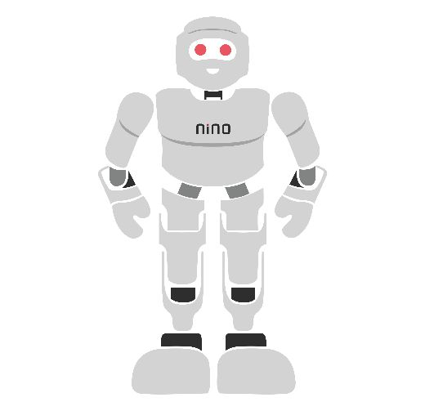
Table of Contents

1. Introduction to Raspberry Pi and Single-Board Computers
2. Raspberry Pi Hardware Overview
3. Installing Raspberry Pi OS
4. Linux Fundamentals I: Command Line and Filesystem
5. Linux Fundamentals II: Permissions, Processes, and Bash Scripting
6. Networking and Remote Access
7. Package Management and Python Environments
8. Remote Development with VS Code
9. Mounting the Raspberry Pi onto the Sirena UBot
10. Module Components and Lab Kit
11. Hands-On Experiments
12. Module Summary and Assessment
13. Glossary of Key Terms

Module Overview
This module introduces the Raspberry Pi 4B as a single-board computer and establishes it as the Sirena UBot's compute brain, working alongside the microcontroller-based motor control covered in Module 1. Across 10 hours of combined theory and hands-on lab work, students move from unboxing the hardware through to a fully networked, remotely accessible Linux system mounted and wired onto the UBot chassis.
Learning Outcomes
By the end of this module, students will be able to:
- Identify the Raspberry Pi 4B's key hardware components, ports, and 40-pin GPIO header pin functions
- Install Raspberry Pi OS using Raspberry Pi Imager, including headless Wi-Fi/SSH pre-configuration
- Navigate the Linux filesystem and manage files, directories, and permissions from the command line
- Manage processes and background services using systemctl, and write simple bash automation scripts
- Configure Wi-Fi, static IP/hostname, SSH, and VNC for reliable headless remote access
- Use apt and pip for package management, and isolate project dependencies using Python virtual environments
- Configure and use VS Code Remote-SSH for a full headless development workflow
- Mount and wire a Raspberry Pi onto the Sirena UBot chassis as its compute brain, ready for Module 3
Prerequisites
Students should have completed Module 1 (C, Embedded C, ESP-32 & Arduino) or have equivalent familiarity with basic electronics and microcontroller concepts. No prior Linux experience is required.

1. Introduction to Raspberry Pi and Single-Board Computers

1.1 What is a Single-Board Computer?
Definition
A Single-Board Computer (SBC) is a complete computer built on a single circuit board, integrating a processor, memory, storage interface, and input/output ports — everything needed to run a full operating system, without requiring separate expansion cards.

Unlike the Arduino Uno and ESP32 covered in Module 1, which run a single compiled program directly on bare hardware, a single-board computer such as the Raspberry Pi boots a full multi-tasking operating system (typically a Linux distribution). This allows it to run multiple programs simultaneously, connect to networks, manage files, and support high-level programming languages such as Python with rich libraries for computer vision, machine learning, and web services.

1.2 The Raspberry Pi Family
The Raspberry Pi Foundation has released several generations of boards since 2012, each improving processing power, memory, and connectivity while maintaining a similar compact form factor and the same 40-pin GPIO header layout since the Raspberry Pi B+ (2014).
Model | Year | Notable Improvement
Raspberry Pi 1 Model B | 2012 | The original board that started the Raspberry Pi project
Raspberry Pi 2 Model B | 2015 | Quad-core processor, significantly faster than Pi 1
Raspberry Pi 3 Model B/B+ | 2016 / 2018 | Added built-in Wi-Fi and Bluetooth
Raspberry Pi 4 Model B | 2019 | USB 3.0, Gigabit Ethernet, dual micro-HDMI (4K), up to 8GB RAM
Raspberry Pi 5 | 2023 | Faster CPU/GPU, PCIe support, improved thermal design

Did You Know?
The Raspberry Pi was originally designed to encourage computer science education in schools. Its low cost and full Linux capability have since made it one of the most widely used platforms in robotics, home automation, and industrial prototyping worldwide.

1.3 Why Raspberry Pi for Robotics?
Module 1 of this course used the Arduino Uno and ESP32 as microcontroller platforms — excellent for real-time, low-level control of motors and sensors, but limited in processing power and unable to run a full operating system. The Raspberry Pi complements these microcontrollers by serving as the robot's high-level "compute brain":
- Runs full Python programs with libraries such as OpenCV, TensorFlow, and Flask
- Connects to Wi-Fi networks and the internet directly, without an external module
- Supports a camera for computer vision tasks
- Can run multiple processes simultaneously - navigation, vision, and a web dashboard at once
- Provides a full Linux command-line and file system for flexible software development
Real-World Example
In many robotics platforms, including the Sirena UBot used later in this module, a microcontroller such as an ESP32 or a dedicated motor driver handles fast, low-level motor control, while a Raspberry Pi handles higher-level decision-making — for example, processing a camera feed to decide where the robot should go, and then sending simple movement commands down to the motor driver.

1.4 Raspberry Pi 4B Technical Specifications
This module standardises on the Raspberry Pi 4 Model B (4B), which offers a strong balance of processing power, connectivity, and cost for educational robotics.
Specification | Value
Processor | Broadcom BCM2711, Quad-core Cortex-A72 (ARM v8) @ 1.5GHz
RAM | 2GB / 4GB / 8GB LPDDR4 (variant dependent)
Wireless | 802.11 b/g/n/ac Wi-Fi, Bluetooth 5.0
Wired Networking | Gigabit Ethernet
USB Ports | 2x USB 3.0, 2x USB 2.0
Video Output | 2x micro-HDMI (dual 4K display support)
GPIO | 40-pin header (same pinout since the B+ generation)
Camera / Display | CSI camera connector, DSI display connector
Storage | microSD card slot (operating system and file storage)
Power Input | USB-C, 5V / 3A recommended
Review Questions
- Explain the key difference between a single-board computer and a microcontroller such as the Arduino Uno.
- List two Raspberry Pi models and one notable improvement each introduced.
- Why is a Raspberry Pi well suited to act as a robot's high-level "compute brain" rather than its only controller?
- How much RAM and what processor does the Raspberry Pi 4B use?
- Name three tasks a Raspberry Pi can perform that a microcontroller such as an ESP32 typically cannot.

2. Raspberry Pi Hardware Overview

2.1 Board Layout and Key Components
Before writing any software, it is essential to be able to identify every major component on the Raspberry Pi board and understand its purpose.
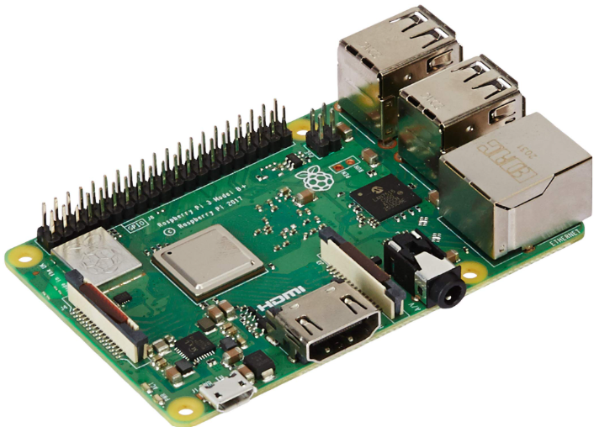
Figure 2.1: A Raspberry Pi single-board computer. (This photograph shows a Raspberry Pi 3 Model B+; the Raspberry Pi 4B used in this module shares the same general board layout, with a USB-C power input, dual micro-HDMI ports, and USB 3.0 as the main visual differences.)
At the centre of the board sits the Broadcom system-on-chip (SoC), which combines the CPU, GPU, and memory controller. Surrounding it are the connectors and headers that give the Raspberry Pi its flexibility as a robotics compute platform.

2.2 Ports and Connectors
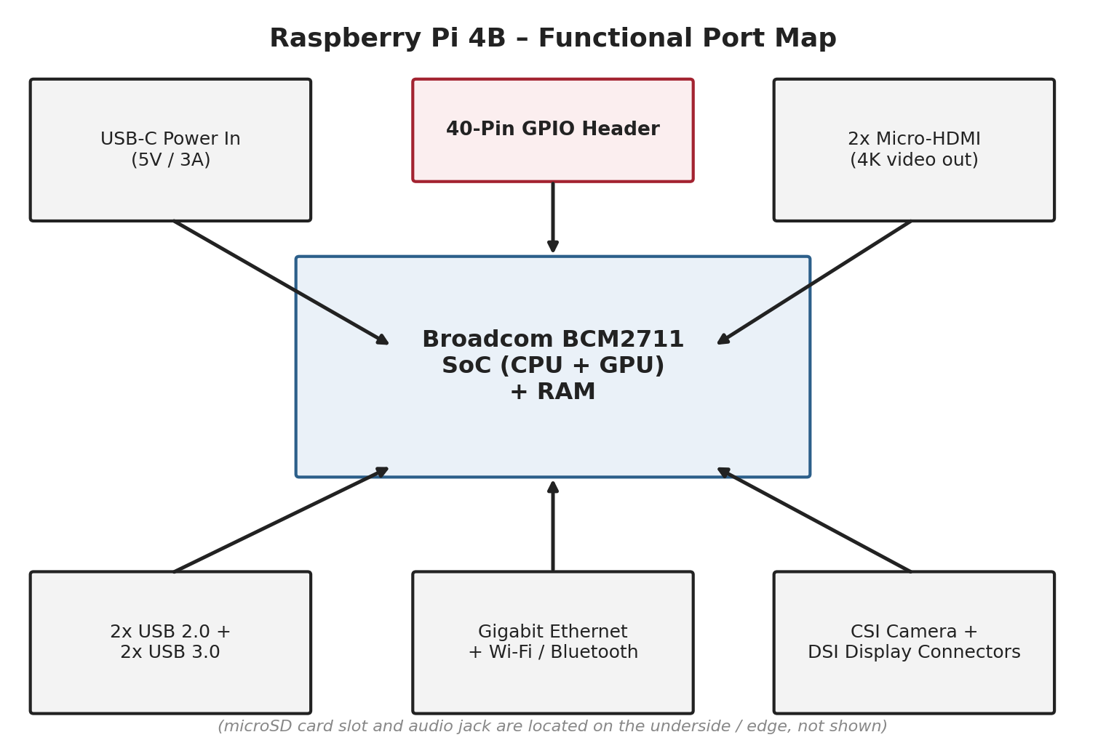
Figure 2.2: Raspberry Pi 4B functional port map.
Port / Connector | Purpose
USB-C Power Input | Supplies 5V power to the board (3A recommended for stable operation with peripherals)
2x Micro-HDMI | Digital video/audio output, supports dual 4K displays
2x USB 3.0 (blue) + 2x USB 2.0 | Connect keyboards, mice, USB storage, and other peripherals
Gigabit Ethernet | Wired network connection
Wi-Fi / Bluetooth (onboard) | Wireless network and short-range device connectivity
40-Pin GPIO Header | General-purpose input/output for sensors, motors, and other electronics
CSI Camera Connector | Connects the official Raspberry Pi Camera Module via ribbon cable
DSI Display Connector | Connects official touchscreen displays directly
microSD Card Slot | Holds the operating system and file storage (located on the underside of the board)
3.5mm Audio/Video Jack | Analog audio output (present on some Pi models)

2.3 The Camera (CSI) and Display (DSI) Connectors
The Camera Serial Interface (CSI) connector accepts a flat ribbon cable from the official Raspberry Pi Camera Module, providing a dedicated high-speed link for video capture that does not consume a USB port — an important consideration for robots that also need USB ports free for other peripherals. The Display Serial Interface (DSI) connector similarly allows an official touchscreen to be driven directly, without occupying an HDMI port.

2.4 The 40-Pin GPIO Header
The GPIO (General Purpose Input/Output) header is the primary way the Raspberry Pi connects to external electronics — sensors, motor drivers, LEDs, and other robotics hardware. It exposes 40 physical pins in two rows of 20, providing power, ground, and configurable signal pins.
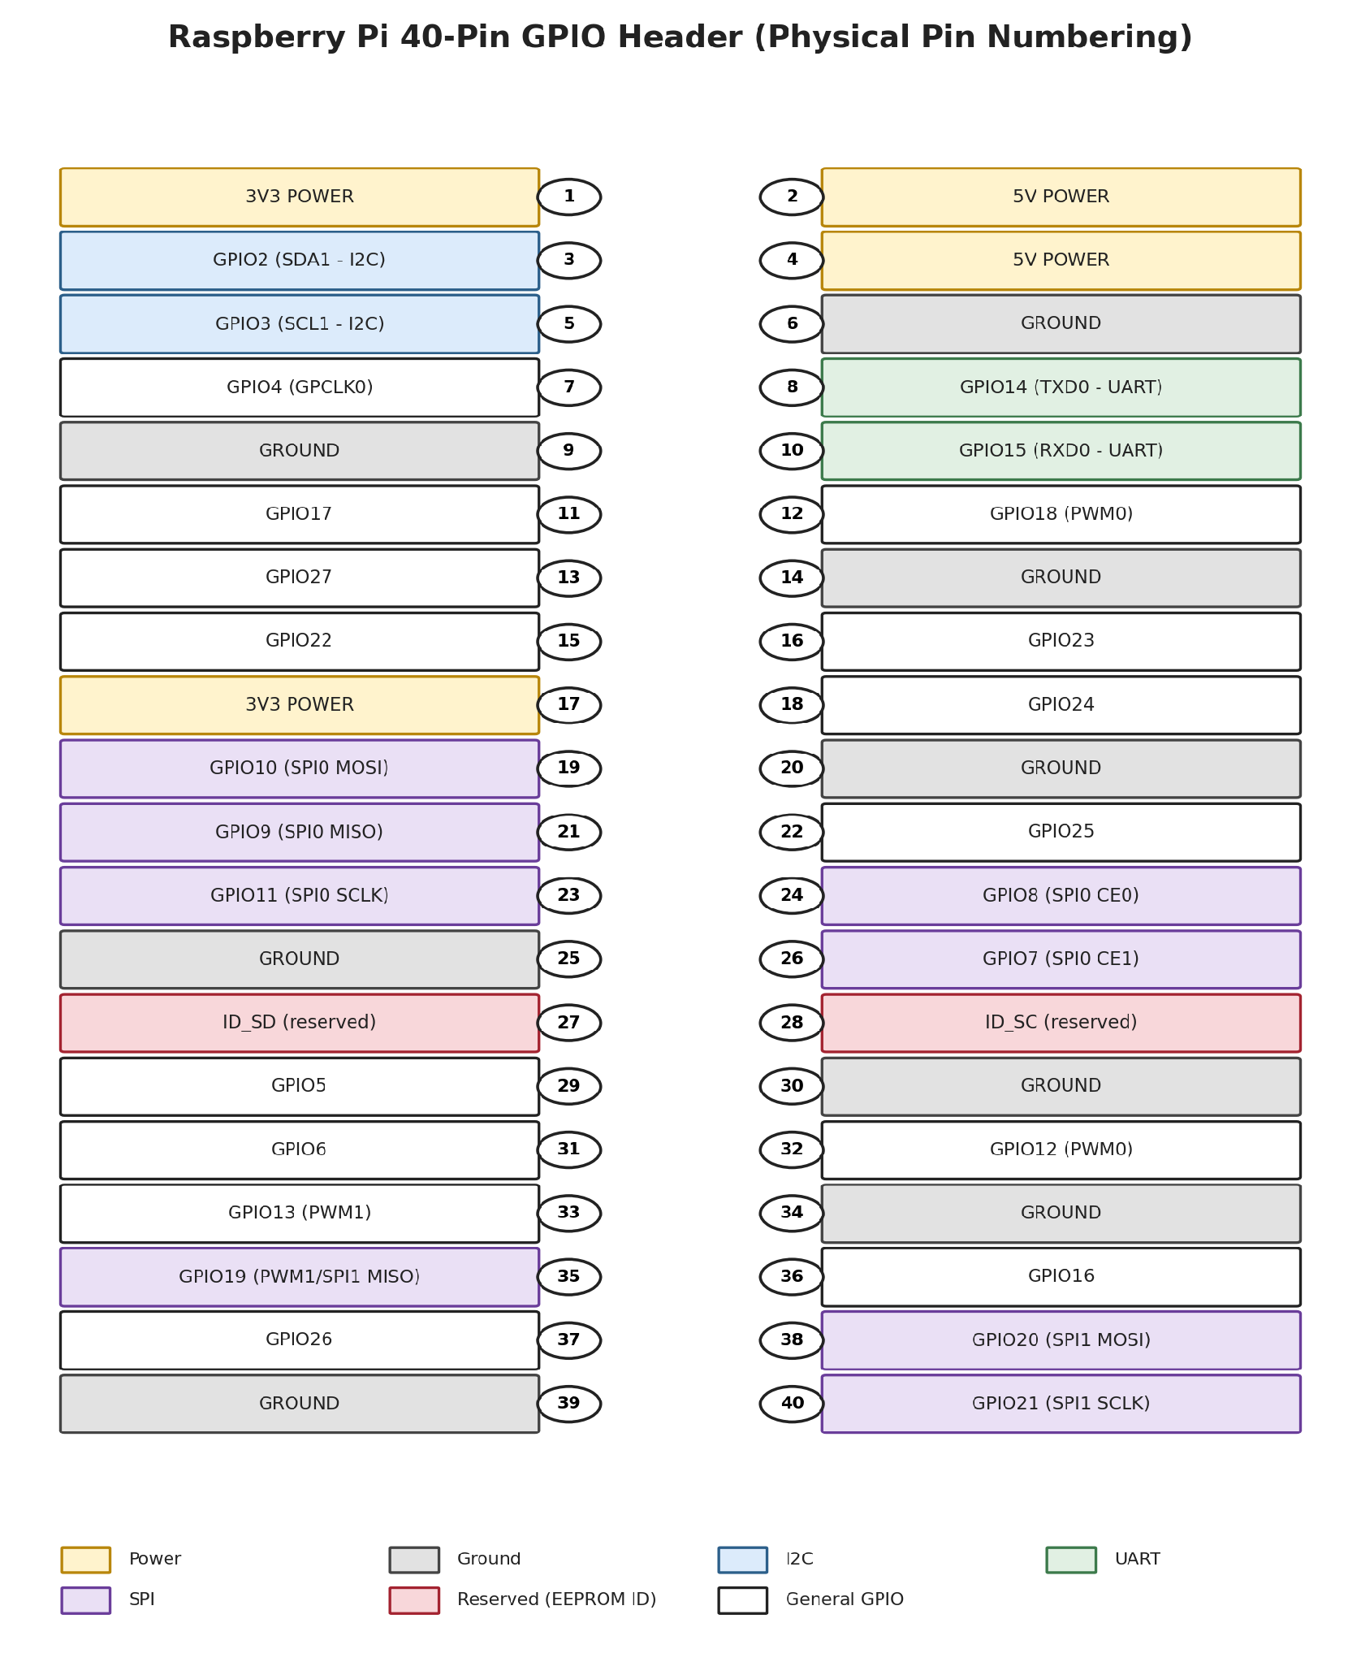
Figure 2.3: The Raspberry Pi 40-pin GPIO header, physical pin numbering.
The header provides four broad categories of pins, all visible in the diagram above:
- Power pins - 3.3V and 5V outputs used to power external sensors and modules
- Ground pins - multiple GND pins distributed across the header for a stable common reference
- General-purpose GPIO pins - digital input/output pins, individually addressable in software
- Dedicated communication pins - fixed pins reserved for UART, SPI, and I2C protocols
Note
Raspberry Pi GPIO pins operate at 3.3V logic, unlike the Arduino Uno's 5V logic covered in Module 1. Connecting a 5V signal directly to a Raspberry Pi GPIO pin can permanently damage the board - a logic level shifter must be used when interfacing with 5V sensors or modules.

2.5 Key Communication Interfaces on the GPIO Header
Interface | Pins Used (BCM numbering) | Typical Robotics Use
UART (Serial) | GPIO14 (TXD), GPIO15 (RXD) | Communicating with a microcontroller such as an ESP32
I2C | GPIO2 (SDA), GPIO3 (SCL) | Connecting sensors such as IMUs, distance sensors, and displays
SPI | GPIO10/9/11 (MOSI/MISO/SCLK), GPIO8/7 (CE0/CE1) | High-speed communication with displays and certain sensors
PWM | GPIO12, GPIO13, GPIO18, GPIO19 | Generating PWM signals for motor speed or servo control
Note the distinction between physical pin numbering (1-40, used when wiring by hand) and BCM (Broadcom) GPIO numbering (used in Python code, e.g. GPIO.setmode(GPIO.BCM)). Both numbering systems are shown in the pinout diagram above and should never be confused when wiring or writing code.

2.6 Lab Kit Components for This Module
Beyond the Raspberry Pi 4B itself, this module's lab kit includes several supporting components used to safely and conveniently prototype GPIO circuits before wiring anything permanently onto the UBot chassis.
GPIO Breakout Board
A GPIO breakout board (sometimes called a T-cobbler breakout) is a small board that plugs into a breadboard and exposes each of the Raspberry Pi's 40 GPIO pins as an individual breadboard-friendly row, with each pin clearly labelled by both physical number and function (e.g. GPIO17, SDA, SCLK). Because the Raspberry Pi's GPIO header itself cannot be inserted directly into a breadboard, the breakout board is the standard way to prototype sensor and motor connections without needing to solder or directly stress the Pi's header pins.
T-Type GPIO Adapter
The T-type GPIO adapter is the small PCB piece that gives the breakout board its characteristic "T" shape, sitting at the edge of the breadboard while its 40 header pins align with the breadboard's rows. It is called "T-type" because of this physical shape, which keeps the labelled pin names easily readable while every pin remains individually accessible for jumper wire connections.
Ribbon Cable
A 40-way ribbon cable (flat, multi-coloured flexible cable) connects the Raspberry Pi's GPIO header directly to the T-type GPIO adapter or breakout board. Using a ribbon cable, rather than plugging the breakout board directly onto the Pi, allows the Raspberry Pi to remain mounted in its enclosure or on the robot chassis while the breadboard prototyping area is positioned conveniently nearby on the workbench.
Breadboard
A solderless breadboard is a reusable prototyping surface with a grid of internally connected holes, allowing components and jumper wires to be inserted and rearranged without soldering. In this module, the breadboard hosts the GPIO breakout board and provides a safe space to wire sensors, LEDs, or test circuits before any permanent connection is made to the UBot's onboard electronics.
Jumper Wires
Jumper wires are short, flexible wires with connector pins on each end, used to make individual connections between breadboard rows, the GPIO breakout board, and external components. Three common types are used depending on the connection required:
- Male-to-Male (M-M) - connects two breadboard rows together
- Male-to-Female (M-F) - connects a breadboard row to a labelled pin header on a sensor module
- Female-to-Female (F-F) - connects two pin headers directly, e.g. two sensor modules together
Review Questions
- Name three ports found on the Raspberry Pi 4B and briefly describe their function.
- Why is the CSI camera connector preferred over a USB webcam in some robotics applications?
- What voltage level does the Raspberry Pi's GPIO header operate at, and why is this important to remember?
- Explain the difference between physical pin numbering and BCM GPIO numbering.
- Describe the role of a GPIO breakout board and why it is needed for breadboard prototyping.
- What type of jumper wire would you use to connect a breadboard row to a sensor's pin header?

3. Installing Raspberry Pi OS

3.1 Choosing an Operating System
Raspberry Pi OS (formerly Raspbian) is the official, Debian-based Linux distribution maintained by the Raspberry Pi Foundation, optimised specifically for Raspberry Pi hardware. It is available in three variants:
Variant | Description | Typical Use
Raspberry Pi OS Lite | Command-line only, no desktop environment | Headless robotics projects with no display attached
Raspberry Pi OS (with desktop) | Full graphical desktop environment | General-purpose use, learning, and development with a monitor
Raspberry Pi OS Full | Desktop plus a large collection of pre-installed applications | Education and general computing
For the UBot platform in this module, Raspberry Pi OS Lite is recommended once students are comfortable with the command line, since it boots faster and uses fewer system resources — leaving more processing power available for robotics software. Earlier in the learning process, however, the desktop variant is useful for becoming familiar with the environment.

3.2 What You Need Before You Begin
- A Raspberry Pi 4B board
- A microSD card (16GB or larger recommended, Class 10 / A1 rated for speed)
- A microSD card reader (USB or built into a laptop)
- A computer with the Raspberry Pi Imager tool installed
- A stable internet connection for downloading the OS image

3.3 Using Raspberry Pi Imager
Raspberry Pi Imager is the official tool for writing an operating system image onto a microSD card, and includes built-in advanced options for pre-configuring Wi-Fi, hostname, and SSH before the card is ever inserted into the Pi — extremely useful for headless setup.
- Download and install Raspberry Pi Imager from the official Raspberry Pi website on your computer
- Insert the microSD card into your computer's card reader
- Open Raspberry Pi Imager and click "Choose Device" to select Raspberry Pi 4
- Click "Choose OS" and select Raspberry Pi OS (Lite or with Desktop, as required)
- Click "Choose Storage" and select the correct microSD card - double-check this to avoid overwriting another drive
- Click the gear/settings icon (or press Ctrl+Shift+X) to open Advanced Options
- Set a hostname (e.g. ubot01), enable SSH, and enter your Wi-Fi SSID and password
- Set a username and password for the Pi's default account
- Click "Save", then "Write", and confirm to begin writing the image to the card
Note
Pre-configuring Wi-Fi and SSH through the Advanced Options menu allows the Raspberry Pi to boot directly onto your network with remote access already enabled — meaning the board never needs to be connected to a monitor, keyboard, or mouse at all, which is exactly how it will be used once mounted on the UBot chassis.

3.4 First Boot and Initial Configuration
Once the microSD card is written, insert it into the Raspberry Pi and apply power. If Wi-Fi and SSH were pre-configured through Raspberry Pi Imager, the board will boot directly onto the network within about 30-60 seconds, ready to accept a remote connection as described in Chapter 6.
If a monitor, keyboard, and mouse are connected instead, the Raspberry Pi OS desktop will guide you through a first-run setup wizard covering region and language settings, Wi-Fi network selection, and software updates.

3.5 Enabling Interfaces via raspi-config
Certain hardware interfaces on the Raspberry Pi - including the camera, I2C, and SPI - are disabled by default and must be explicitly enabled using the raspi-config tool before they can be used.
$ sudo raspi-config

# Navigate to: Interface Options
# -> Camera -> Enable
# -> SSH -> Enable
# -> I2C -> Enable
# -> SPI -> Enable
# Select <Finish> and reboot when prompted
raspi-config can also be used to expand the filesystem to fill the entire microSD card, change the default password, set the hostname, and configure locale/timezone settings — making it one of the first tools every Raspberry Pi user should become comfortable with.
Review Questions
- What are the three variants of Raspberry Pi OS, and when would you choose each?
- List the minimum items required before writing an operating system image to a microSD card.
- What advantage does pre-configuring Wi-Fi and SSH in Raspberry Pi Imager provide for a robotics project?
- Which tool is used to enable the camera, I2C, and SPI interfaces after the OS has booted?
- Why might Raspberry Pi OS Lite be preferred over the desktop variant for the final UBot deployment?

4. Linux Fundamentals I: Command Line and Filesystem

4.1 What is Linux and Why It Matters for Robotics
Linux is a free, open-source operating system kernel that forms the foundation of Raspberry Pi OS and the vast majority of embedded and server systems used in robotics and industry. Unlike the graphical, mouse-driven interfaces most students are used to, Linux is traditionally operated through a text-based command line — a skill that becomes essential once the Raspberry Pi is running headless (without a monitor) on a robot chassis.
Learning the command line is not simply an alternative way to do the same tasks as a graphical interface — it enables automation, remote administration, and precise control that graphical tools often cannot match, all of which are central to professional robotics development.

4.2 The Linux Filesystem Hierarchy
Every file and folder on a Linux system exists within a single unified tree, starting from the root directory, written as a forward slash: /. Unlike Windows, there are no separate drive letters — every storage device is "mounted" as a folder somewhere within this same tree.
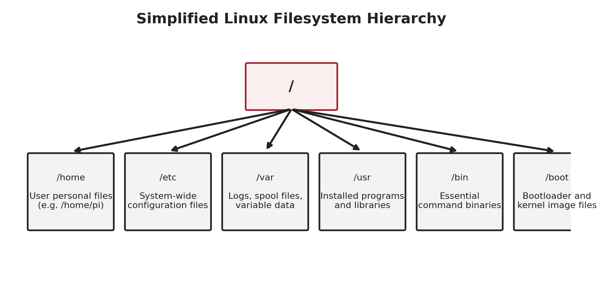
Figure 4.1: Simplified Linux filesystem hierarchy.
Directory | Contents
/ | The root of the entire filesystem
/home/pi | The default user's personal files and projects
/etc | System-wide configuration files (e.g. network settings)
/var | Variable data such as logs and temporary spool files
/usr | Installed application programs and shared libraries
/bin, /usr/bin | Essential command-line program binaries
/boot | Bootloader files and the Linux kernel image
/dev | Device files representing hardware (e.g. /dev/ttyUSB0 for a serial port)

4.3 Navigating the Filesystem
A small number of commands account for the vast majority of everyday Linux navigation:
$ pwd
/home/pi

$ ls
Desktop Documents Downloads ubot_project

$ ls -l
drwxr-xr-x 2 pi pi 4096 Jul 20 10:15 ubot_project

$ cd ubot_project
$ pwd
/home/pi/ubot_project

$ cd ..
$ pwd
/home/pi

Command | Purpose
pwd | Print Working Directory - shows the current folder location
ls | List the contents of the current directory
ls -l | List contents with details: permissions, owner, size, date
cd <folder> | Change Directory into the named folder
cd .. | Move up one directory level
cd ~ | Jump straight to the current user's home directory

4.4 Creating and Managing Files and Directories
$ mkdir sensors
$ cd sensors
$ touch read_ultrasonic.py
$ ls
read_ultrasonic.py

$ cp read_ultrasonic.py read_ultrasonic_backup.py
$ mv read_ultrasonic_backup.py ../backups/
$ rm read_ultrasonic_backup.py
$ cd ..
$ rmdir sensors # only works if the folder is empty

Command | Purpose
mkdir <name> | Create a new directory
rmdir <name> | Remove an empty directory
touch <file> | Create a new empty file (or update its timestamp)
cp <src> <dest> | Copy a file or directory
mv <src> <dest> | Move or rename a file or directory
rm <file> | Delete a file (rm -r for a directory and its contents)

Note
The rm command deletes files permanently - there is no Recycle Bin on a typical Linux command line. Always double-check the file or folder name before pressing Enter, especially when using the -r (recursive) or -f (force) flags.

4.5 Viewing and Editing Files
Two commands are used constantly when working with configuration files and Python scripts on a headless Raspberry Pi: cat, which prints a file's entire contents to the screen, and nano, a simple, beginner-friendly text editor that runs directly inside the terminal.
$ cat read_ultrasonic.py
import RPi.GPIO as GPIO
import time
...

$ nano read_ultrasonic.py
# Opens the file in the nano editor.
# Ctrl+O then Enter -> save the file
# Ctrl+X -> exit nano

4.6 Useful Command Combinations
Linux commands become significantly more powerful when combined using pipes (|), which send the output of one command directly into another as input.
$ ls -l | grep .py # list only files ending in .py
$ cat sensor_log.txt | tail -n 20 # view only the last 20 lines of a log
$ history | grep python # search previously run commands for "python"
Review Questions
- What is the purpose of the root directory (/) in the Linux filesystem hierarchy?
- Which command shows the full path of the directory you are currently in?
- Write the command to create a new directory called logs and move into it in a single sequence.
- What is the difference between the mv and cp commands?
- Why should the rm command be used with particular caution?
- Explain what the pipe symbol (|) does when placed between two commands.

5. Linux Fundamentals II: Permissions, Processes, and Bash Scripting

5.1 Understanding File Permissions
Every file and directory on a Linux system has an associated set of permissions, controlling who may read, write, or execute it. Running ls -l reveals these permissions as a 10-character string at the start of each line.
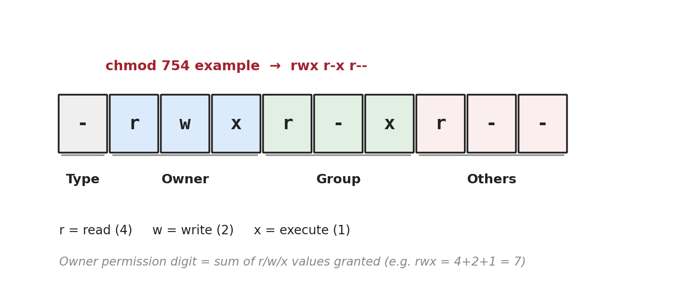
Figure 5.1: Breakdown of a Linux file permission string.
The first character indicates the file type (- for a regular file, d for a directory). The remaining nine characters are split into three groups of three (read, write, execute) for the file's owner, its group, and all other users respectively.

5.2 Changing Permissions with chmod
The chmod (change mode) command modifies a file's permissions, either using symbolic letters or a three-digit numeric shorthand where read=4, write=2, and execute=1 are added together for each of owner/group/others.
$ ls -l read_ultrasonic.py
-rw-r--r-- 1 pi pi 512 Jul 20 09:00 read_ultrasonic.py

$ chmod 755 read_ultrasonic.py # rwx for owner, r-x for group and others
$ ls -l read_ultrasonic.py
-rwxr-xr-x 1 pi pi 512 Jul 20 09:00 read_ultrasonic.py

$ ./read_ultrasonic.py # can now be executed directly

Note
A Python script must have its execute permission set (chmod +x) and begin with a shebang line (#!/usr/bin/env python3) before it can be run directly with ./scriptname.py. Otherwise, it must be run explicitly with python3 scriptname.py.

5.3 What is a Process?
Definition
A process is a running instance of a program. Linux can run many processes simultaneously, each with its own process ID (PID), and the operating system's scheduler shares CPU time between them.

$ ps aux | grep python
pi 1423 0.3 1.2 15234 9876 ? Sl 10:02 0:01 python3 ubot_main.py

$ kill 1423 # stops the process with PID 1423

5.4 Managing Services with systemctl
Many long-running programs on a robot — such as a Python script that should start automatically every time the Raspberry Pi boots — are best managed as a systemd service, rather than being started manually each time. The systemctl command controls these background services.
$ sudo systemctl status ssh
$ sudo systemctl start ubot.service
$ sudo systemctl stop ubot.service
$ sudo systemctl enable ubot.service # start automatically on every boot
$ sudo systemctl restart ubot.service

Real-World Example
In Module 3, the UBot's main Python control program will be configured as a systemd service, so that the robot automatically starts running its navigation and control software the moment it is powered on - with no need to manually log in and type a command every time.

5.5 Introduction to Bash Scripting
Bash is the default command-line shell on Raspberry Pi OS, and is also a simple scripting language in its own right. A bash script is a plain text file containing a sequence of commands that would otherwise be typed manually, one after another.
#!/bin/bash
# A simple bash script - update_system.sh

echo "Updating package lists..."
sudo apt update

echo "Upgrading installed packages..."
sudo apt upgrade -y

echo "Done!"
- The first line, #!/bin/bash, is called a shebang and tells Linux which interpreter should run the script
- echo prints text to the terminal
- Variables are created without a data type: name="UBot" and referenced with a dollar sign: echo $name
- Conditionals use if / then / fi, and loops use for / do / done
#!/bin/bash
for i in 1 2 3 4 5
do
echo "Checking sensor $i..."
done

if [ -f "sensor_log.txt" ]; then
echo "Log file found."
else
echo "Log file missing!"
fi

5.6 Writing and Running Your First Script
$ nano update_system.sh # write the script contents
$ chmod +x update_system.sh # make it executable
$ ./update_system.sh # run it
Review Questions
- What does the permission string -rwxr-xr-- indicate about a file's owner, group, and other-user access?
- Write the chmod numeric command that grants full permissions to the owner and read-only to everyone else.
- What is a process, and what command can be used to list currently running processes?
- Why would a robotics program be configured as a systemd service instead of being run manually each time?
- What is the purpose of the shebang line at the top of a bash script?
- Write a short bash for-loop that prints "Motor test N" for N from 1 to 3.

6. Networking and Remote Access

6.1 Configuring Wi-Fi on Raspberry Pi
If Wi-Fi was not pre-configured through Raspberry Pi Imager, it can be set up after boot using the raspi-config tool or the desktop network manager. From the command line:
$ sudo raspi-config
# System Options -> Wireless LAN -> enter SSID and password

$ iwconfig # view current wireless connection status
$ ping -c 4 google.com # verify internet connectivity

6.2 Static IP Address and Hostname Configuration
By default, a Raspberry Pi is assigned a dynamic IP address by the network's DHCP server, which can change between reboots — inconvenient when repeatedly reconnecting to a robot for development. Two solutions are commonly used:
- Static IP address - manually fixing the Pi's IP address so it never changes
- Hostname - accessing the Pi by a friendly name (e.g. ubot01.local) instead of a numeric IP address, using mDNS (multicast DNS), which Raspberry Pi OS supports out of the box
$ sudo nano /etc/dhcpcd.conf

# Add at the end of the file:
interface wlan0
static ip_address=192.168.1.50/24
static routers=192.168.1.1
static domain_name_servers=192.168.1.1

Note
The hostname set during Raspberry Pi Imager setup (e.g. ubot01) can be reached from most computers simply as ubot01.local, without needing to know or configure its IP address at all - this is usually the simplest option for a classroom robotics lab.

6.3 SSH: Secure Shell Remote Access
Definition
SSH (Secure Shell) is an encrypted network protocol that provides secure command-line access to a remote computer over a network, allowing commands to be typed and executed on the Raspberry Pi from another computer entirely.
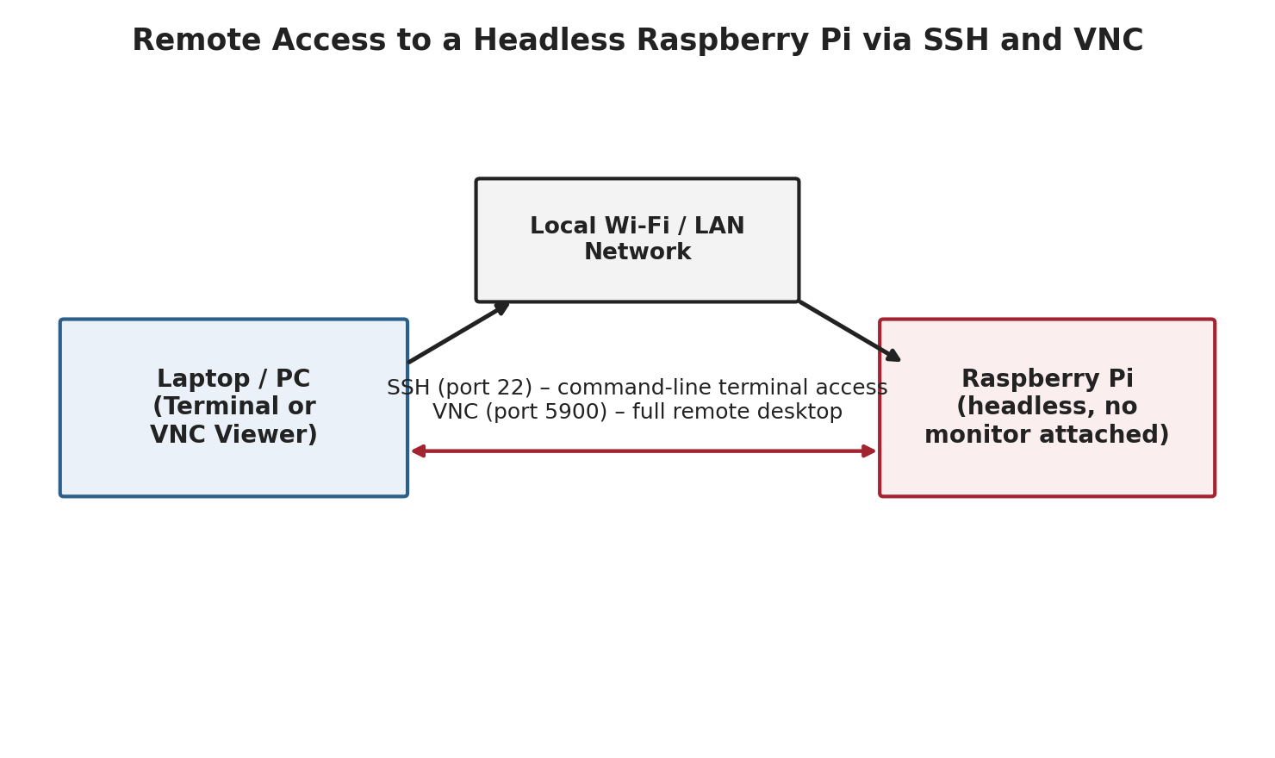
Figure 6.1: Remote access to a headless Raspberry Pi via SSH and VNC.
$ ssh pi@ubot01.local
pi@ubot01.local's password: ********

pi@ubot01:~ $ # you are now working directly on the Raspberry Pi
Once connected, every command typed runs on the Raspberry Pi itself, exactly as if a keyboard and monitor were physically attached to it — this is the primary way the Pi will be operated once mounted on the UBot chassis.

6.4 VNC: Remote Desktop Access
Definition
VNC (Virtual Network Computing) provides full remote access to a computer's graphical desktop over the network, allowing the mouse, windows, and applications to be seen and controlled remotely, not just the command line.

$ sudo raspi-config
# Interface Options -> VNC -> Enable
After enabling VNC on the Raspberry Pi, a VNC Viewer application (such as RealVNC Viewer) installed on a laptop can connect using the Pi's hostname or IP address, displaying its full desktop in a window on the remote computer.

6.5 SSH vs VNC: Choosing the Right Tool
Aspect | SSH | VNC
Interface | Text-based command line only | Full graphical desktop
Bandwidth Usage | Very low | Higher - transmits screen images
Typical Use | Running scripts, editing code, quick commands | Using graphical tools, viewing camera preview windows
Speed | Very fast, even over slow connections | Can feel sluggish on slow networks
Security | Encrypted by default | Encrypted when configured correctly
In practice, most day-to-day robotics development uses SSH for its speed and simplicity, with VNC reserved for occasions when a graphical tool or live camera preview window is genuinely needed.
Review Questions
- What problem does setting a static IP address or hostname solve for a headless Raspberry Pi?
- Explain what the .local suffix does when accessing a Raspberry Pi by its hostname.
- Write the SSH command used to connect to a Raspberry Pi with hostname ubot01 and username pi.
- What is the key difference between what SSH and VNC each provide access to?
- In what situation would VNC be a better choice than SSH for a robotics task?

7. Package Management and Python Environments

7.1 The APT Package Manager
APT (Advanced Package Tool) is the package manager used by Raspberry Pi OS and other Debian-based Linux distributions to install, update, and remove system-level software from official repositories.
$ sudo apt update # refresh the list of available packages
$ sudo apt upgrade -y # upgrade all installed packages
$ sudo apt install git -y # install a new package (e.g. git)
$ sudo apt remove git # remove a package
$ apt list --installed # list all currently installed packages

Note
Always run sudo apt update before installing new software. This refreshes APT's local list of available package versions, ensuring you install the latest compatible release rather than an outdated cached entry.

7.2 Installing Python Packages with pip
While APT manages system-level software, pip (Pip Installs Packages) is Python's own package manager, used to install Python libraries such as those needed for robotics, computer vision, and web servers.
$ python3 --version
Python 3.11.2

$ pip3 install RPi.GPIO
$ pip3 install opencv-python
$ pip3 install flask
$ pip3 list # show installed Python packages

7.3 Python Virtual Environments (venv)
Definition
A Python virtual environment is an isolated, self-contained Python installation with its own independent set of installed packages, separate from the system-wide Python installation and from any other project's virtual environment.

Without virtual environments, installing a specific package version for one project can silently break another project that depends on a different, incompatible version of the same package. Virtual environments solve this by giving every project its own clean, isolated set of dependencies.
$ python3 -m venv ubot_env # create a new virtual environment
$ source ubot_env/bin/activate # activate it
(ubot_env) $ pip install opencv-python numpy
(ubot_env) $ python3 vision_test.py
(ubot_env) $ deactivate # leave the virtual environment
Notice how the terminal prompt changes to show (ubot_env) once the environment is active — a useful visual reminder of which Python environment is currently in use.

7.4 Best Practices for Dependency Management
- Create a separate virtual environment for each robotics project
- Record installed packages using pip freeze > requirements.txt
- Recreate an identical environment elsewhere using pip install -r requirements.txt
- Avoid using sudo pip install, which installs packages system-wide and can conflict with Raspberry Pi OS's own Python tools
(ubot_env) $ pip freeze > requirements.txt
(ubot_env) $ cat requirements.txt
opencv-python==4.9.0.80
numpy==1.26.4
flask==3.0.2
Review Questions
- What is the difference between the roles of apt and pip on Raspberry Pi OS?
- Why should sudo apt update be run before installing a new package?
- Explain, in your own words, why Python virtual environments are useful on a shared robotics project.
- Write the two commands needed to create and then activate a virtual environment named test_env.
- What is the purpose of a requirements.txt file, and how is it generated?

8. Remote Development with VS Code

8.1 Why Headless Development?
Once mounted on the UBot chassis, the Raspberry Pi will typically run without a monitor, keyboard, or mouse attached — a configuration known as headless operation. While nano and the command line (Chapter 4) are perfectly capable of editing code directly over SSH, a full code editor with syntax highlighting, file browsing, and integrated debugging makes larger Python projects significantly easier to develop and maintain.
Visual Studio Code (VS Code) solves this with its Remote-SSH extension, which allows the editor's graphical interface to run on your laptop while all files, code execution, and terminals actually run on the Raspberry Pi itself, over an SSH connection.

8.2 Installing and Configuring VS Code Remote-SSH
- Install Visual Studio Code on your laptop or desktop computer
- Open the Extensions panel and install the "Remote - SSH" extension by Microsoft
- Press Ctrl+Shift+P (or Cmd+Shift+P on Mac) to open the Command Palette
- Type and select "Remote-SSH: Connect to Host..."
- Enter the connection string, e.g. pi@ubot01.local
- Select the correct SSH configuration file when prompted, and enter the Pi's password when asked
- Wait for VS Code to install its server components on the Raspberry Pi (first connection only)
- Once connected, choose File > Open Folder to browse and open a project directory on the Pi

8.3 Editing and Running Code Remotely
Once connected, VS Code behaves almost identically to editing files locally — except every file shown, every terminal opened, and every program executed is actually running on the Raspberry Pi. This means Python libraries such as RPi.GPIO, which only function on real Raspberry Pi hardware, work correctly during development and testing, not just at final deployment.
# The integrated terminal in VS Code, once connected via Remote-SSH,
# is a real terminal session running directly on the Raspberry Pi:

pi@ubot01:~/ubot_project $ python3 test_motor.py

8.4 Tips for a Smooth Remote Workflow
- Keep the Raspberry Pi's hostname and SSH enabled at all times during development, as configured in Chapters 3 and 6
- Use VS Code's built-in Git integration to track changes to robot code over time
- Activate the correct Python virtual environment inside the VS Code integrated terminal before running any script
- Use the Explorer panel to drag and drop files between your laptop and the Raspberry Pi when needed
Sirena Connection
This exact remote development setup — Raspberry Pi running headless on the UBot chassis, edited and controlled entirely through VS Code Remote-SSH from a laptop — is the standard workflow used throughout Sirena Technologies' Python-based robotics modules, starting with Module 3.
Review Questions
- Why is headless operation the typical configuration for a Raspberry Pi mounted on a robot chassis?
- Which VS Code extension enables editing files that live on a remote Raspberry Pi?
- Where does code actually execute when using VS Code Remote-SSH - on the laptop or on the Raspberry Pi?
- Why is it important to activate the correct Python virtual environment inside the VS Code terminal before running a script?
- Name one advantage of using VS Code's Remote-SSH workflow over editing files directly with nano.

9. Mounting the Raspberry Pi onto the Sirena UBot

9.1 The Raspberry Pi as the UBot's Compute Brain
With Raspberry Pi OS installed, Linux fundamentals understood, and remote access configured, the Raspberry Pi is now ready to take its place as the Sirena UBot's central compute brain. In this role, the Pi is responsible for higher-level decision-making — running Python programs, processing camera input, hosting a control web page, and issuing movement commands — while lower-level, time-critical motor control is handled by the UBot's dedicated motor driver board.

9.2 Physical Mounting on the Chassis
The Raspberry Pi 4B should be mounted securely to the UBot chassis using its four corner mounting holes, standoffs, and small screws, positioned so that its USB, HDMI, and power ports remain accessible and its GPIO header is oriented toward the motor driver board for the shortest practical wiring run.
- Ensure the microSD card is fully inserted before mounting, as it can be difficult to access once the chassis is assembled
- Leave clearance around the Pi for airflow - the BCM2711 processor can run warm under sustained robotics workloads
- Route the camera ribbon cable (if used) away from motor wiring to reduce electrical interference
- Secure all cables with cable ties or clips to prevent them catching in wheels or moving parts

9.3 Wiring the Raspberry Pi to the UBot Motor Driver
The Raspberry Pi communicates with the UBot's motor driver board through a small number of GPIO pins, sending direction and speed commands exactly as the Arduino Uno and ESP32 did with the L298N driver in Module 1 — the concepts of digital output and PWM signal control carry over directly, this time issued from Python code instead of embedded C.
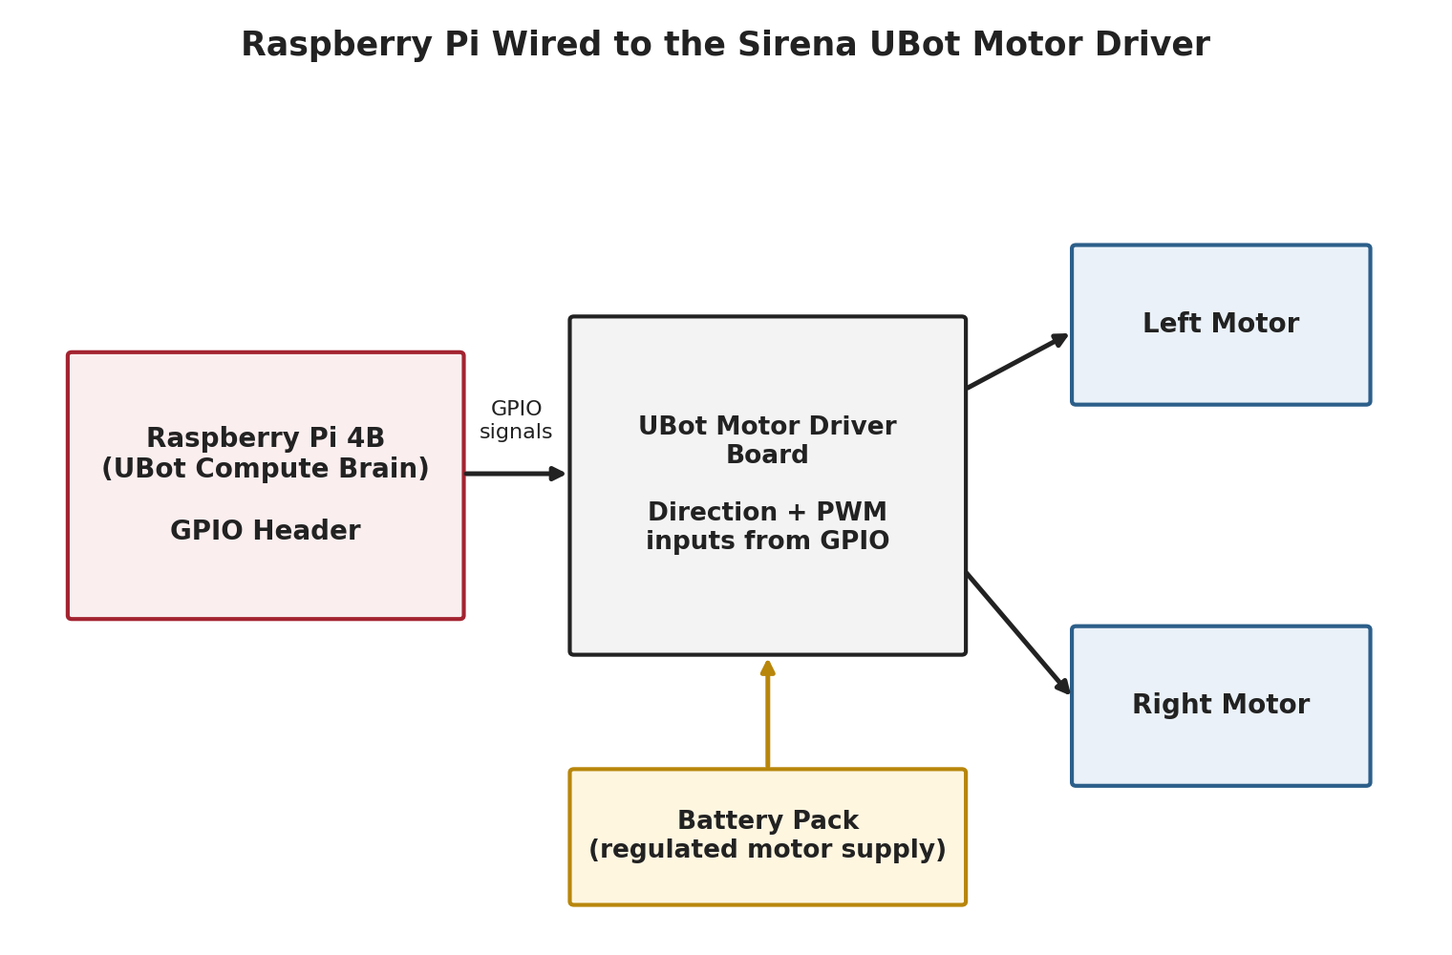
Figure 9.1: Raspberry Pi wired to the Sirena UBot motor driver.
Note
Because the Raspberry Pi's GPIO pins operate at 3.3V while many motor driver boards expect 5V logic-level inputs, always confirm the UBot motor driver's input voltage tolerance before wiring directly. Where required, a logic-level shifter should be placed between the Pi's GPIO pins and the driver's control inputs.

9.4 Power Considerations
The Raspberry Pi 4B requires a stable 5V/3A supply, which is considerably more current than a small microcontroller draws, and must be kept electrically separate from the higher-current, noisier motor power supply.
- Use a dedicated, regulated 5V supply for the Raspberry Pi - do not share this directly with raw motor battery voltage
- Always connect a common ground between the Raspberry Pi, the motor driver, and the battery pack
- Monitor for the small lightning-bolt icon in the desktop menu bar (or the under-voltage warning in dmesg on headless systems), which indicates the Pi is not receiving adequate power
$ dmesg | grep -i voltage
[ 12.345678] Under-voltage detected! (0x00050005)

9.5 Preparing for Python Programming in Module 3
With the Raspberry Pi mounted, wired, and remotely accessible, the UBot platform is now ready for the Python programming work that begins in Module 3, including GPIO control from Python, sensor integration, and camera-based computer vision — all built on the Linux foundation established in this module.
Module 2 Skill | How It Will Be Used in Module 3
Linux command line | Running, debugging, and managing Python scripts on the UBot
SSH and VNC remote access | Developing and testing code without a monitor attached to the robot
Python virtual environments | Installing and isolating libraries such as OpenCV and RPi.GPIO
GPIO header knowledge | Writing Python code that reads sensors and drives the motor controller
systemctl services | Launching the UBot's control software automatically on power-up
Review Questions
- What role does the Raspberry Pi play on the UBot platform, and what role does the motor driver play?
- List two physical mounting considerations that should be observed when installing the Pi on the chassis.
- Why must the Raspberry Pi's power supply be kept separate from the motor battery supply?
- What command or indicator can reveal that the Raspberry Pi is experiencing an under-voltage condition?
- Name three Linux or networking skills from this module that will be directly used in Module 3.

10. Module Components and Lab Kit

10.1 Components Used in This Module
The following hardware components are used across the lab sessions in this module. Students should verify that all items are present and undamaged before beginning any exercise.
Component | Purpose in This Module
Raspberry Pi 4B Board | Primary single-board computer and the UBot's compute brain
microSD Card (16GB+) | Stores Raspberry Pi OS and all project files
USB-C Power Supply (5V/3A) | Powers the Raspberry Pi during development
GPIO Breakout Board | Exposes all 40 GPIO pins individually onto a breadboard
T-Type GPIO Adapter | Physical adapter connecting the ribbon cable to the breakout board
40-Way Ribbon Cable | Connects the Raspberry Pi's GPIO header to the breakout board
Breadboard | Prototyping surface for sensor and circuit testing
Jumper Wires (M-M, M-F, F-F) | Circuit interconnections between breadboard, breakout board, and modules
Laptop / PC | Used for Raspberry Pi Imager, SSH, VNC, and VS Code Remote-SSH
Wi-Fi Network Access | Required for OS setup, remote access, and package installation

10.2 Safety Guidelines for the Lab
- Always power off the Raspberry Pi safely using sudo shutdown -h now before removing power - abruptly cutting power can corrupt the microSD card's filesystem
- Never hot-plug the GPIO header or breakout board while the Raspberry Pi is powered on
- Double-check wiring against the GPIO pinout diagram before connecting any sensor or motor driver signal
- Never connect a 5V signal directly to a Raspberry Pi GPIO pin without a logic-level shifter
- Handle the Raspberry Pi board by its edges to avoid electrostatic discharge (ESD) damage to components
- Keep liquids away from the breadboard and Raspberry Pi at all times

11. Hands-On Experiments

11.1 Mini Experiment 1: Linux Command Line and Bash Automation on Raspberry Pi
- Objective: Practice core Linux navigation, file management, and permissions commands, then automate a repeatable task using a bash script
- Components: Raspberry Pi 4B (with Raspberry Pi OS installed), keyboard and monitor or an active SSH session
Procedure
- Open a terminal (or connect via SSH) and confirm your current location using pwd
- Create a project directory called ubot_lab1 and move into it using mkdir and cd
- Create three empty files named sensor1.py, sensor2.py, and sensor3.py using touch
- List the directory contents in long format using ls -l and record the default permissions shown
- Use nano to write a short bash script named system_check.sh that prints the current date, disk usage, and memory usage
- Make the script executable using chmod +x, then run it using ./system_check.sh
- Modify the script to loop through and print the names of all three sensor Python files created earlier
#!/bin/bash
# system_check.sh
echo "Date: $(date)"
echo "Disk usage:"
df -h /
echo "Memory usage:"
free -h

echo "Sensor files in this project:"
for f in sensor*.py
do
echo " - $f"
done
- Expected Outcome: Students demonstrate confident use of navigation, file management, and permission commands, and produce a working bash script that automates a small system-check and file-listing task

11.2 Mini Experiment 2: Remote Raspberry Pi Access using SSH and VNC
- Objective: Configure and use both SSH and VNC to access a Raspberry Pi remotely from a laptop, without a monitor permanently attached to the Pi
- Components: Raspberry Pi 4B (headless), laptop/PC on the same Wi-Fi network, SSH client, VNC Viewer application
Procedure
- Confirm the Raspberry Pi's hostname (set during Raspberry Pi Imager setup) and that SSH is enabled
- From a laptop terminal, connect using ssh pi@<hostname>.local and enter the password when prompted
- Once connected, run hostname and ip a to confirm you are working on the Raspberry Pi and note its IP address
- Enable VNC on the Raspberry Pi using sudo raspi-config (Interface Options > VNC > Enable)
- Install a VNC Viewer application on the laptop, and connect using the Pi's hostname or IP address
- Open a terminal window within the VNC desktop session and run a simple command such as ls to confirm functionality
- Compare the responsiveness of SSH versus VNC over the classroom Wi-Fi network and record your observations
$ ssh pi@ubot01.local
pi@ubot01.local's password: ********
pi@ubot01:~ $ hostname
ubot01
pi@ubot01:~ $ ip a | grep inet
inet 192.168.1.50/24 brd 192.168.1.255 scope global wlan0
- Expected Outcome: Students successfully establish both an SSH session and a VNC graphical session to the same headless Raspberry Pi, and can explain the practical differences between the two remote access methods

12. Module Summary and Assessment

12.1 Module Summary
This module introduced the Raspberry Pi 4B as a single-board computer capable of serving as a robot's high-level compute brain, complementing the microcontroller-based control covered in Module 1. Students examined the Raspberry Pi's hardware in detail - its ports, its 40-pin GPIO header, and the supporting lab-kit components (GPIO breakout board, T-type adapter, ribbon cable, breadboard, and jumper wires) needed to prototype circuits safely.
After installing Raspberry Pi OS using Raspberry Pi Imager, students built a working foundation in Linux: navigating the filesystem, managing file permissions, controlling processes and services, and writing bash scripts to automate repetitive tasks. Networking skills - Wi-Fi configuration, static IP/hostname setup, SSH, and VNC - enabled fully headless operation, while package management with apt and pip, combined with Python virtual environments and VS Code Remote-SSH, established a professional remote development workflow. The module concluded by physically mounting the Raspberry Pi onto the Sirena UBot chassis and wiring it to the motor driver, preparing the platform for Python-based robotics programming in Module 3.

12.2 Learning Outcomes Recap
- Identify the Raspberry Pi 4B's key hardware components, ports, and GPIO header pin functions
- Install Raspberry Pi OS using Raspberry Pi Imager, including headless Wi-Fi/SSH pre-configuration
- Navigate the Linux filesystem and manage files, directories, and permissions from the command line
- Manage processes and background services using systemctl, and write simple bash automation scripts
- Configure Wi-Fi, static IP/hostname, SSH, and VNC for reliable headless remote access
- Use apt and pip for package management, and isolate project dependencies using Python virtual environments
- Configure and use VS Code Remote-SSH for a full headless development workflow
- Mount and wire a Raspberry Pi onto the Sirena UBot chassis as its compute brain

12.3 Consolidated Assessment Questions
- Compare the role of the Raspberry Pi in this module with the role of the Arduino Uno and ESP32 in Module 1.
- Describe, step by step, how you would prepare a microSD card for a completely headless Raspberry Pi setup.
- Explain the function of each of the following GPIO header pin categories: power, ground, UART, SPI, and I2C.
- Write a short bash script that creates a folder called logs and moves any file ending in .log into it.
- A student cannot SSH into their Raspberry Pi. List three possible causes and how each could be diagnosed.
- Explain why Python virtual environments are considered good practice, using a concrete example.
- Outline the full remote development workflow a student would use to edit and test Python code on a headless UBot.

13. Glossary of Key Terms
Term | Definition
APT | Advanced Package Tool - the system-level package manager on Raspberry Pi OS
Bash | The default Linux command-line shell, and a simple scripting language
BCM Numbering | A GPIO numbering scheme based on Broadcom chip pin names, used in Python code
Headless | Operating a computer without a monitor, keyboard, or mouse attached
Hostname | A friendly network name for a device, usable in place of its IP address
GPIO | General Purpose Input/Output - configurable pins used to connect external electronics
mDNS | Multicast DNS - the technology that allows a Pi to be reached via its .local hostname
pip | Python's package manager, used to install Python libraries
Process | A running instance of a program, identified by a unique process ID (PID)
Root Directory | The top-level directory (/) containing the entire Linux filesystem
Shebang | The #! line at the top of a script specifying which interpreter should run it
SSH | Secure Shell - an encrypted protocol for remote command-line access
systemd / systemctl | Linux's service manager, and the command used to control background services
Venv | A Python virtual environment - an isolated set of Python packages for one project
VNC | Virtual Network Computing - a protocol providing full remote desktop access
chmod | The Linux command used to change a file's read/write/execute permissions

